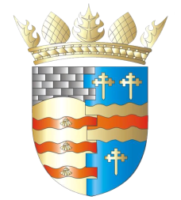**BLAIRGOWRIE AND RATTRAY COMMUNITY COUNCIL**

**Draft Agenda - Annual General Meeting & Ordinary Meeting**

**Thursday, 9th October 2025, at 7pm**

**in Rattray, Thomson Suite, Davie Park Football Grounds**

**and online via Zoom**

**Annual General Meeting**

1. Welcome and Introductions/Apologies
2. Adoption of 2024 AGM draft minutes
3. Chair’s Annual Report
4. Treasurer’s Annual Report
5. Date of next AGM: 8th October 2026

**Ordinary Meeting**

1. Welcome and Introductions

2. Apologies

3. Adoption of draft minutes of 11th September 2025 meeting  
4. Police & Fire Reports

a) Riverside safety

5. Matters raised by members of the public

6. Matters Arising/Reports Back

a) Emma Street laundry

b) Football Pitch

c) Gallowbank Footpath

d)Top up tap

e) Remembrance Day wreath

7. Regular reports

a) Representation of Young People

b) Resilience/Flooding/First Responders PR/SM

c) Climate Action DC/GP/JM

d) Twinning GP/SM/DC/AS

e) Maintenance in Blairgowrie & Rattray

i. Built Environment

a) Electrical Connections at Wellmeadow

ii. Open Spaces

8. Pool update

9. Traffic Matters

a) Speeding Meeting

10. Planning Matters

11. Chair’s Report

12. Treasurer’s Report

13. Councillors’ Reports

14. AOCB

Please note: With the permission of all attendees, the minute taker will record this meeting solely for the purpose of writing up the minutes, will not share the recording, and will delete the recording as soon as the minutes have been written. The Chair will ask for permission at the start of the meeting.

Awaiting info: CCTV, Community Action Plan, Local Place Plan, Citizen of the Year

**Next meeting: EGM & Ordinary Meeting, Thursday, 13th November 2025, 7.00pm,**

**at the BaRI Building, Blairgowrie, & online**